Lab 6: Code and Branch Coverage Analysis
Student Name: Hitha Shree Suresh | SRN: PES2UG24CS196
Section: D | Assigned Module: bookstore_trade_in.py

1. Code Coverage Analysis
Commands: coverage run -m pytest CodeCoverageTest_bookstore_trade_in.py
coverage report -m
- Implementation: 12 test cases in CodeCoverageTest_bookstore_trade_in.py covering all 57 statements.
- Results: 57/57 statements covered, 0 missed -> 100% Line Coverage (Requirement: >= 90%). 12 passed in 0.06s.
Test Case | Target Statements / Logic | Expected Outcome
test_single_paperback_good | Paperback ($8 base, good condition) | Payout: $8.0, COMPLETED
test_invalid_batches_input | Guard clause: batches not a list (lines 2-3) | ValueError raised
test_unapproved_batch_skipped | Intake approval guard (intake_approved=False) | Batch skipped, payout $8.0
test_unsupported_format_rejected | Unknown format rejection (lines 22-23) | Batch rejected, payout $8.0
test_missing_pages_rejected | Condition missing_pages > 0 (lines 33-34) | Book rejected, payout $8.0
test_textbook_format_and_counterfeit | Textbook format ($40) & counterfeit break | Payout: $0.0, ZERO_CREDIT
test_hardcover_mint_credit_bonus | Hardcover ($15) * mint (1.25) + $10 bonus | Payout: $28.75, COMPLETED
test_paperback_poor_and_counterfeit | Poor condition (0.4x) + non-textbook counterfeit | Payout: $3.20, COMPLETED
test_audit_rejected_status | Threshold rejected_items > 4 (line 55) | Status: AUDIT_REJECTED
test_scanner_no_data | Empty scanner matrix (lines 62-63) | Returns NO_DATA
test_scanner_recalibrate | Error rates > 5 triggering recalibration | Returns RECALIBRATE
test_scanner_calibrated | Error rates <= 5 resetting streak | Returns CALIBRATED

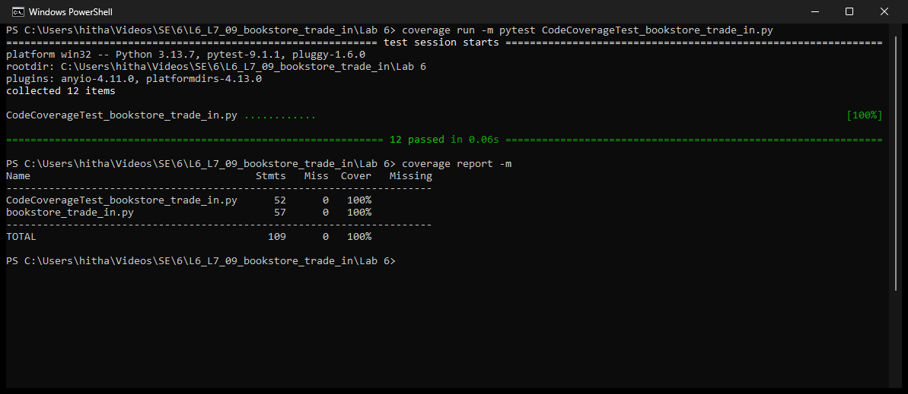
Figure 1: Code Coverage Terminal Output (100% Line Coverage)

2. Branch Coverage Analysis
Commands: coverage run --branch -m pytest BranchCoverageTest_bookstore_trade_in.py
coverage report -m
- Implementation: 24 test cases in BranchCoverageTest_bookstore_trade_in.py evaluating True and False paths on all decisions.
- Results: 40/40 branches covered, 0 missed -> 100% Branch Coverage (Requirement: >= 90%). 24 passed in 0.07s.
Decision Point / Condition | Line | True Branch Tested | False Branch Tested
not isinstance(batches, list) | 2 | String input -> raises ValueError | Valid list -> execution proceeds
store_credit_bonus < 0 | 2 | Negative bonus -> raises ValueError | Valid bonus -> execution proceeds
not batch.get('intake_approved') | 9 | approved=False -> batch skipped | approved=True -> batch processed
format_type == 'textbook' | 15 | Textbook -> base price $40.0 | Other format -> checks hardcover
format_type == 'hardcover' | 17 | Hardcover -> base price $15.0 | Other format -> checks paperback
format_type == 'paperback' | 19 | Paperback -> base price $8.0 | Unknown format -> rejected
pages_missing > 0 | 32 | Pages missing -> item rejected | Pages missing == 0 -> checks counterfeit
is_counterfeit and textbook | 38 | Counterfeit textbook -> break, payout 0 | Non-textbook / legitimate book
condition == 'mint' / 'poor' | 42 | Mint (1.25x), Poor (0.40x) multipliers | Good / other -> 1.0x multiplier
payout_in_credit == True | 49 | Bonus added to batch payout | Bonus not added
rejected_items > 4 | 54 | 5 rejected items -> AUDIT_REJECTED | <= 4 rejected -> checks payout
error_rate > 5 (scanner) | 70 | Error > 5 -> increments streak | Error <= 5 -> resets streak to 0

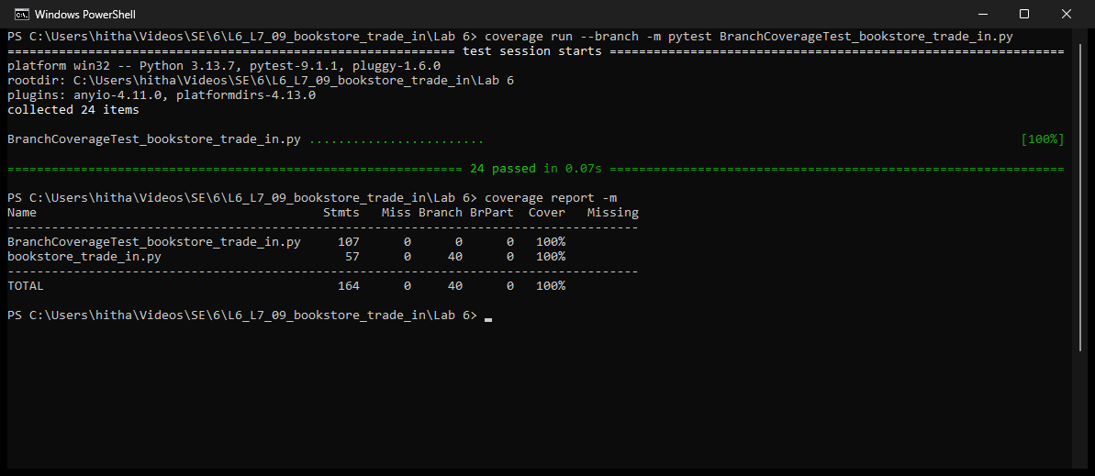
Figure 2: Branch Coverage Terminal Output (100% Branch Coverage)

3. Line Coverage vs. Branch Coverage Analysis
- Line Coverage: Measures whether each line of code was reached during execution.
- Branch Coverage: Measures whether every control construct (if, elif, loop conditions) evaluated to both True and False.
Why Line Coverage Alone Gives a False Sense of Security: Line coverage only indicates that execution reached a statement. If an 'if' construct has no corresponding 'else' branch, testing only the True condition achieves 100% statement coverage for that block, leaving the False path completely untested.
- Store Credit Bonus (Line 49): Testing only payout_in_credit=True executes the bonus addition, satisfying line coverage. The False path (where no bonus is added) is skipped. Any regression or state failure when bonus is not applied would go undetected.
- Scanner Streak Reset (Line 70): Testing only error_rate > 5 increments the error counter, covering that line. Branch coverage requires testing error_rate <= 5 to verify that clean scans properly reset the counter (consecutive_misreads = 0).

4. Git Commit History
Commit Hash | Commit Message | Files Committed
b027b4c | Add code coverage test suite achieving 100% line coverage and terminal screenshot | CodeCoverageTest_bookstore_trade_in.py  screenshots/code_coverage_analysis.png  .gitignore
fa10ccb | Add branch coverage test suite achieving 100% branch coverage and terminal screenshot | BranchCoverageTest_bookstore_trade_in.py  test_bookstore_trade.py  screenshots/branch_coverage_analysis.png  screenshots/baseline_initial_coverage.png
d7b2a17 | Add comprehensive lab report deliverables (DOCX, PDF, and Markdown) | Lab_6_Report.md  PES2UG24CS196_Hitha_Shree_Suresh.docx  PES2UG24CS196_Hitha_Shree_Suresh.pdf

